

Version Number: 1.0

Version Date: 2019-05-06



Revision Log

|  |  |  |  |
| --- | --- | --- | --- |
| Version | Date | Author | Change Description |
| 0.1 | 2019-03-28 | Deanna Beauchamp | Initial Version |
| 0.2 | 2019-04-23 | Deanna Beauchamp | Filling in sections |
| 1.0 | 2019-05-06 | Deanna Beauchamp | Final Revisions for Phase 1 |
|  |  |  |  |

Contents

1. Overview 3

1.1. Summary 3

1.2. Target Audience 3

2. Architecture 3

2.1. Entity Relationship Diagram 4

2.2. Environments 5

2.2.1. Development 5

2.2.2. QA 5

3. Related and Relevant Systems 6

3.1. Exchange Integration 6

3.2. Source Control 6

4. Assumptions 6

4.1. Environment – We will be able to use Dynamics 365 in the cloud 6

4.2. Email - We will be able to use the Dynamics 365 App for Outlook 6

4.3. Credentials - The users of the system will have IDIR accounts 6

# Overview

## Summary

This document describes the high-level system architecture as well as any related or relevant systems.

## Target Audience

The target audience for this document is business analysts, project managers and developers familiar with Dynamics CRM.

# Architecture

This system is build using Microsoft Dynamics 365 version 9.1. It is hosted online through azure. The out of the box system was customized to tailor the system to fit the business needs using a variety of methods including apps, custom entities, forms, and both server-side and client-side code.

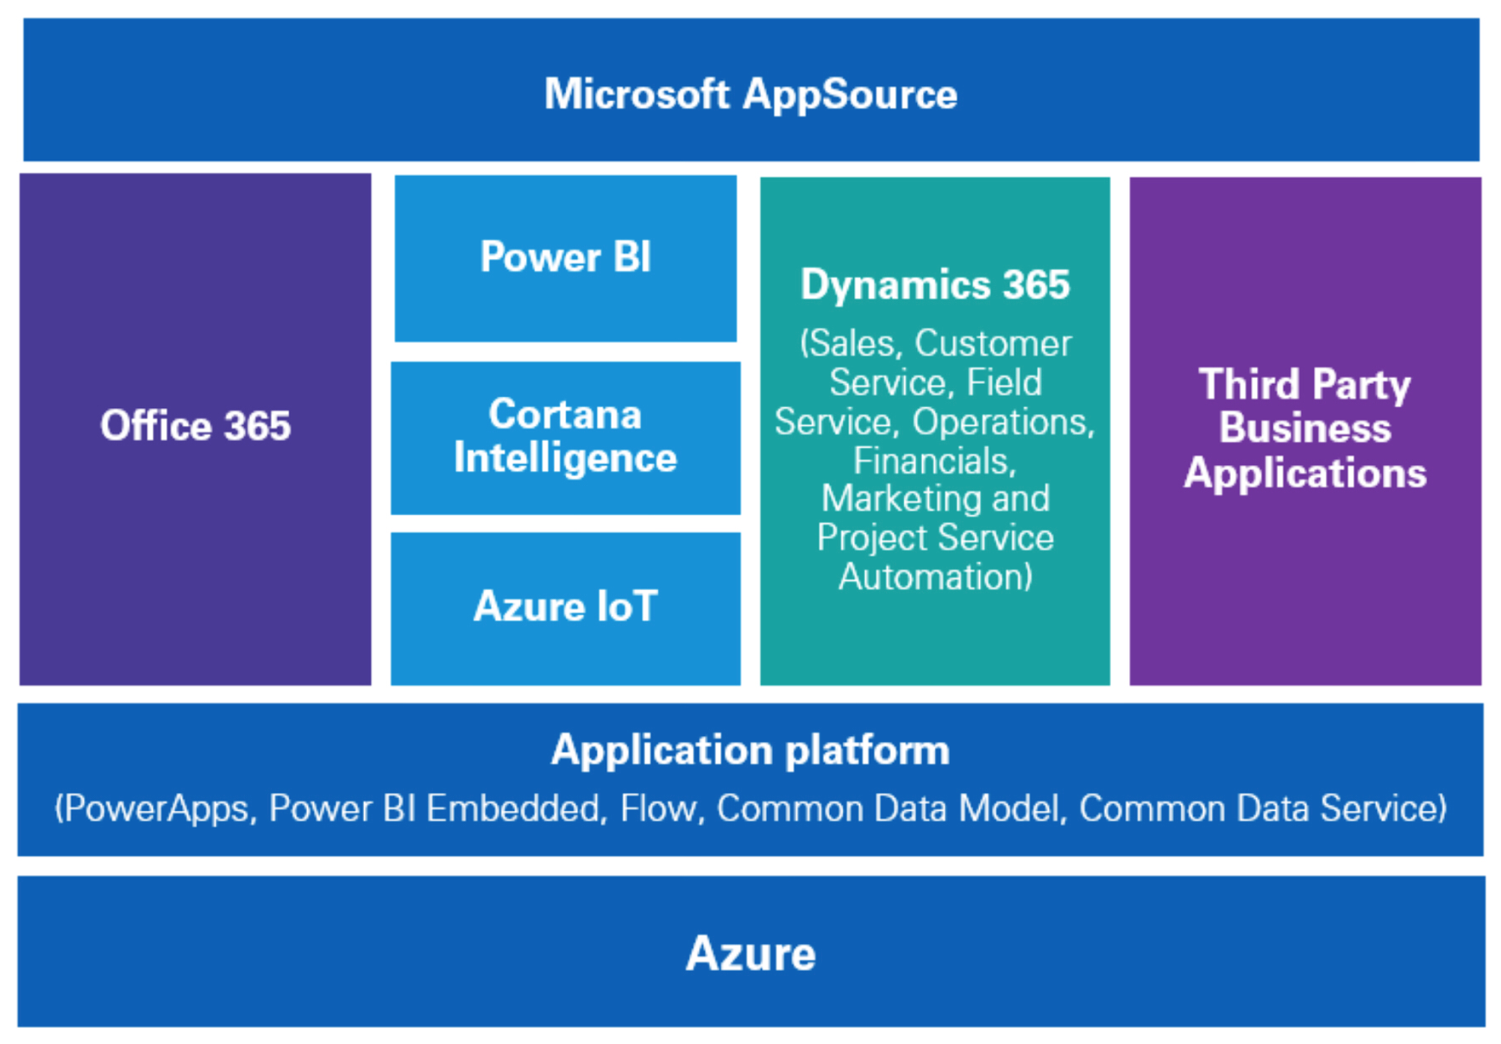

User authentication is done via IDIR syncing with Azure AD which is part of the office 365 suite.

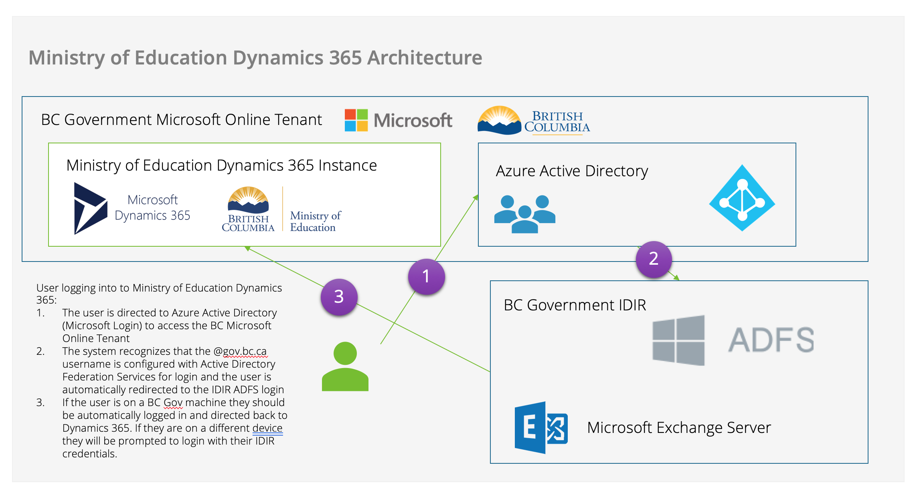

## Entity Relationship Diagram

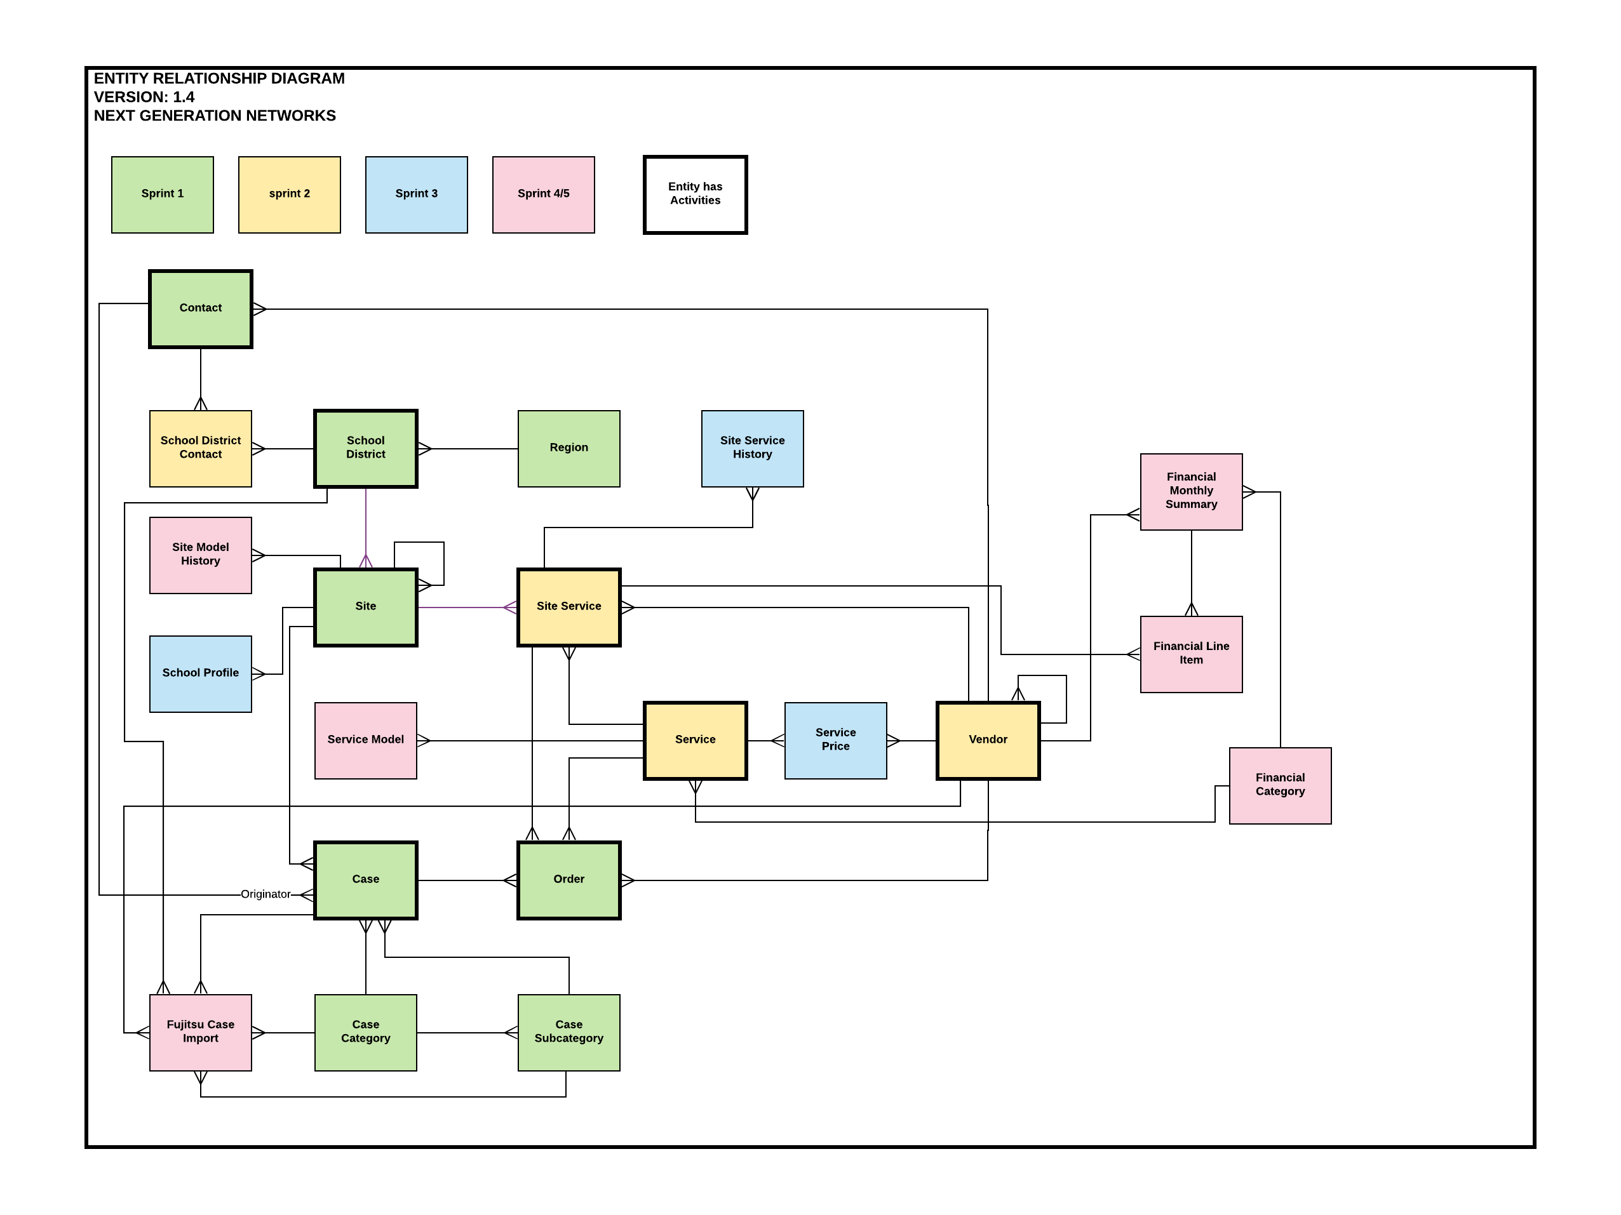

## Environments

### Development

|  |  |
| --- | --- |
| **System** | **URL** |
| Dynamics 365 | <https://ngndev.crm3.dynamics.com> |
| NGN App | <https://ngndev.crm3.dynamics.com/apps/ngn> |

### QA

|  |  |
| --- | --- |
| **System** | **URL** |
| Dynamics 365 | <https://ngn-qa.crm3.dynamics.com/main.aspx> |
| NGN App | <https://ngn-qa.crm3.dynamics.com/apps/ngn> |

# Related and Relevant Systems

## Exchange Integration

Emails will be sent from Dynamics CRM automatically using Microsoft Exchange but emails will not be read automatically into the system. This is to prevent the potential of private information ending up in the cloud. Instead, the users will use the Dynamics 365 Outlook plugin to manually tag and import emails into the system once their content has been reviewed.

## Source Control

This project currently uses ITK’s Azure Dev Ops with GIT for source control. Code will also be included in a zip file at the end of this project.

# Assumptions

## Environment – We will be able to use Dynamics 365 in the cloud

We are building the system with the expectation that will be able to deploy to the cloud but will not use any features not supported by the on-premise version.

## Email - We will be able to use the Dynamics 365 App for Outlook

The system users will have the dynamics 365 app for outlook installed on their machines and will be able to track emails and contacts from their outlook.

## Credentials - The users of the system will have IDIR accounts

The system users will use their IDIR credentials to access the dynamics system